Toxic Comment Classifier

¹B.Naseeba, ²Likith Ganesh.S, ³Shaik Mahammad Irfan ,
¹Assistant Professor, ^{2,3}UG –Student
^{a,b,c,d}School of Computer Science and Engineering (SCOPE), VIT-AP University, Amaravati, India
beebi.naseeba@vitap.ac.in, likithganesh.21bce9479@vitapstudent.ac.in
irfan.21bce9547@vitapstudent.ac.in.

Abstract: We live in a world where everything is done by the means of internet. You may find a person who cannot afford food but not the one who doesn’t use social media. Social media has become part of one’s day to day activities. It is used by people to express their views, exchange information and to influence others. It’s doesn’t surprise if someone claims Social Medial has become the ultimate weapon in the world. With this weapon so called Social media, patrons in these recent times leave countless comments on various social media platforms, news portals, and forums. Most of these comments are informative, convincing and has person’s own perspective but sometimes these might be hateful, aggressive, conflicting with other’s beliefs and all. These types of comments might affect others mindset mentally and these comments need to be moderated, this will be not as easy as it’s said as we have many comments to classify. To detect these types of toxic comments from a large volume we mainly use machine learning models. Because of these machine’s efficiency, fastness and neural network type we can process information from a large dataset. Thus, to protect users from the toxic comments, immature conversations and filthy type in the comments and posts. We used the Deep Learning models like Bi-directional LSTMs, Sequential model, binary cross entropy and Adam optimizer to detect the toxic words in the comments based on the toxic percentage. We conclude our work with a well mentioned list of existing research gaps and recommendations for future endeavors in the research on topic of toxic comment classification.

Keywords: Long Short-Term Networks (LSTMS), Embedding Layers, Multi class classification, binary cross entropy, Adam optimizer.

1 INTRODUCTION
The core problem of the people is the toxic conversations and that is the reason why the people are worried to express their views and spread their innovative ideas. People's biggest issue is with poisonous interactions, which is why they are reluctant to share their opinions and forward their ideas. Due to the fear of having issues, being plagued by others, and experiencing troubles themselves.The objective of this project is to apply deep learning to identify toxicity in text, which might be used to assist users in avoiding sending potentially damaging messages, engaging in more civil discourse with others, and evaluating the remarks of other users.
To achieve the stated objective, this study will employ a range of deep learning models, such as multilayer perceptrons (MLPs), long short-term memory networks (LSTMs), while evaluating how well they perform on classification tasks with binary and multiple labels.

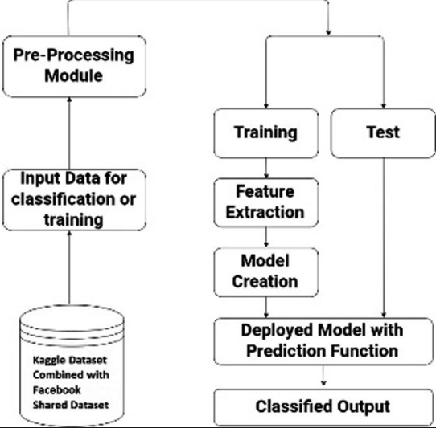

Figure 1. Process Flow of the Model.

Initially we test this model in the domains of public and private sectors to get the perspective of these different minded people on what they think is toxic.Online forums and social media platforms have allowed people to openly express their ideas and opinions on a range of topics and circumstances. In certain cases, the language in these internet comments could be harmful to the readers. The categories for comments that contain explicit language include Severe Toxic, Toxic, Threat, Obscene, Identity Hate, and Insult to name just a few. Due to their fear of abuse or harassment, many people refrain from speaking their minds and seeking out opposing opinions.
To filter out toxic language and protect internet users from abuse and bullying online, several machine learning models have been developed and put to use. In this, we've forecasted the level of toxicity of the comment made by the user based on the tokenized values.
2 RELEVANT STUDY
Haralabopoulos et al (2020) worked on the Deep Learning based Multilabel Binary Haralabopoulos et al.'s Deep Learning-based Multilabel Binary Classification of comments was completed in 2020. To improve precise forecasts and trustworthy generalization, this model combines the results of individual models.According to the researchers, models enhance crucial components of representation, computing, statistics, and learning, and these techniques lessen the issue of incorrect data display. Additionally, they made an effort to reduce the possibility of biased data being used in the training of a single model. While the majority of deep learning algorithms look for solutions that demonstrate the best solution. It uses the Wikipedia dataset. This model predicts 75% of cases with a 1.5% to 5.4% error. The Empirical Assessment of Temporal Convolutional Network for Classification of Offensive Text (Babu & N.D.). The researchers assessed how well the TCN network searched and classify foul language based on its criminal content with the CNN, GRU and LSTM. When compared to LSTM and GRU, TCN has parallelism and can retrieve long-term history using residual blocks and convolutions.Based on the f1 score of the toxic remarks, these results suggest that TCN outperforms GRU, LSTM, and RNN versions.Crespi, Farahbakhsh, and Mozafari(2019) studied LSTM and convolutional neural networks in Online User Comments. The researchers described a supervised model based on deep neural networks for classifying comments made by online users based on their assertions.They also experimented with it by training datasets of online user comments with long short-term memory networks (LSTMs) and Convolution Neural Networks (CNN). They employed various distributional word embedding techniques.. The researchers made a significant improvement on one dataset by classifying remarks as emotive or factual. Le, Ho, Lee, and Jung (2019) developed an LSTM-based method for classifying short text sentiment with word embeddings. Deep learning algorithms like LSTM and word embeddings in social media classification were employed by the researchers to determine sentiment polarity from brief texts. To begin, the words in the postings are converted into vectors using word embeddings. The word sequence in phrases is then sent into LSTM, which learns the long-distance contextual relationship between words. The results demonstrated that deep learning methods can perform effectively when enough and sufficient training data is provided through social media. The amount of training data influences performance. The categorization performance for informal comments is lower and greater for movie reviews. However, when compared to ELM and NB, LSTM performs better. This demonstrates the applicability of an LSTM-based technique for short-text sentiment classification.
d'Sa, Illina, and Fohr (2020) worked on BERT and rapid Text Embeddings for Toxic Speech Detection. Using deep-learning algorithms and embedded words, the researchers suggested an automatic model for the classification of harmful speech.
Using deep-learning algorithms and embedded words, the researchers suggested an automatic model for the classification of harmful speech. They used a Twitter dataset to perform binary and multi-class classification (a) utilizing a DNN classifier to extract word embeddings; and (b) a pre-trained BERT model. Finally, we concluded that the BERT model outperforms the others significantly. The methods described above can be used to different types of social media produced comments. According to the researchers, the BERT model outperformed feature-based techniques on a Twitter corpus.

3 Proposed methodology

3.1 Dataset

- Created Date
We will be using a single CSV dataset for testing and training.

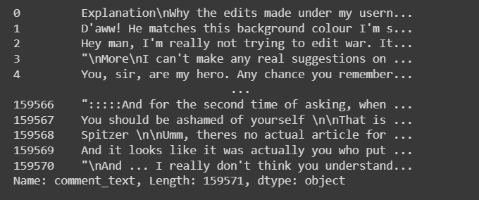
Figure 2. Details about the train dataset.

2. Comment_text: This is the data in string format is used to find find the toxicity.
3. Target: Target values which are to be predicted (has values between 0 and 1)
4.Dataalso has additional toxicity subtype attributes:(Model doe snot have to predict these) severe_toxicity, obscene, threat, insult, identity_attack, sexual_explicit.
5. Comment_text data also has identity attributes carved out from it, some of which are:Male, female, homosexual_gay_or_lesbian, christian, jewish, muslim, black, white, asian, latino, psychiatric_or_mental_illness.
6. Apart from above features the train data also provides meta-data from jigsaw like: toxicity_annotator_count, identity_anotator_count, article_id, funny, sad, wow, likes, disagree, publication_id, parent_id, article_id.

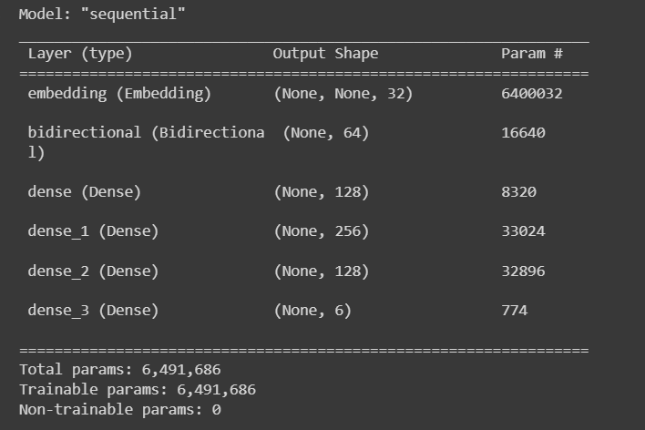

Figure 3. Summary of the Model

  - Type of Machine Learning Problem:
The amount of toxicity (target attribute) must be predicted. The value range is 0 to 1, inclusive. This is an instance of regression. It can also be viewed as a classification problem if we consider all values less than 0.5 to be non-toxic and all values more than 0.5 to be dangerous, yielding a binary classification problem.
3.3 Performance Metric:
The ROC_AUC metric will be used in the competition after converting the numeric target variable to a categorical variable with a threshold of 0.5. Any 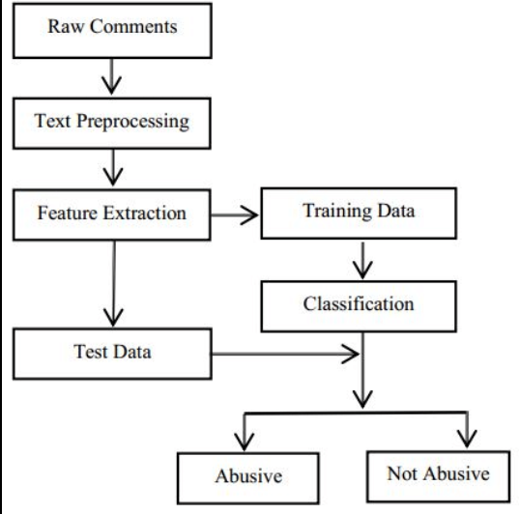

comment above 0.5 is presumed to be hazardous, while those below it are assumed to be non-toxic. We will use the MSE (Mean Squared Error) for training and evaluation.
  - Machine Learning Objectives and Constraints:
LSTM model in the above proposed model.
Objectives:
Predict the toxicity of a comment made by the user. (0 -> not toxic, 1 -> highest toxicity level)
Constraints:
    - The model should be fast to predict the toxicity rating.
    - Interpretability is not needed.

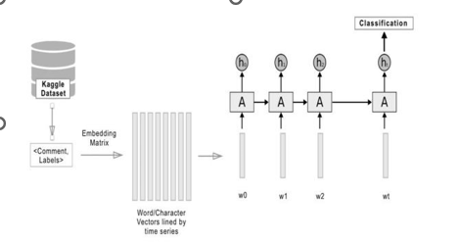

Figure 4. Toxic comments classification.

4 Experimental Results
Based on the training dataset we classified the toxic comments with the parameters such as insult, obscene, identity_attack, threat, severe_toxicity.

Result of Epoch based long short termmemory (LSTM) approach has higher achievement than the Ensemble Deep Learning approach.
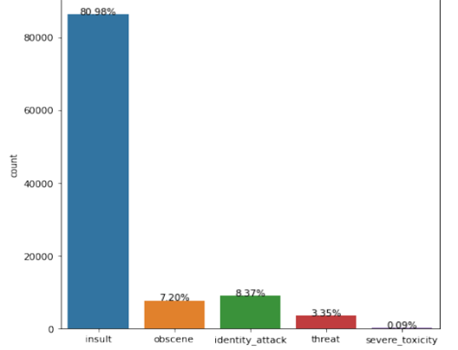

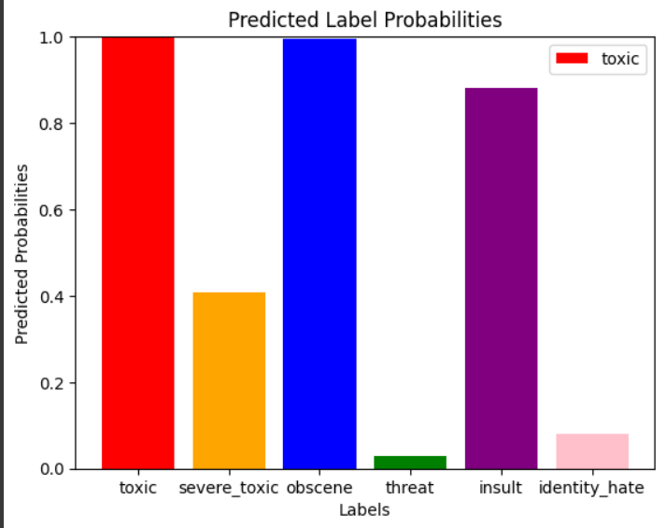

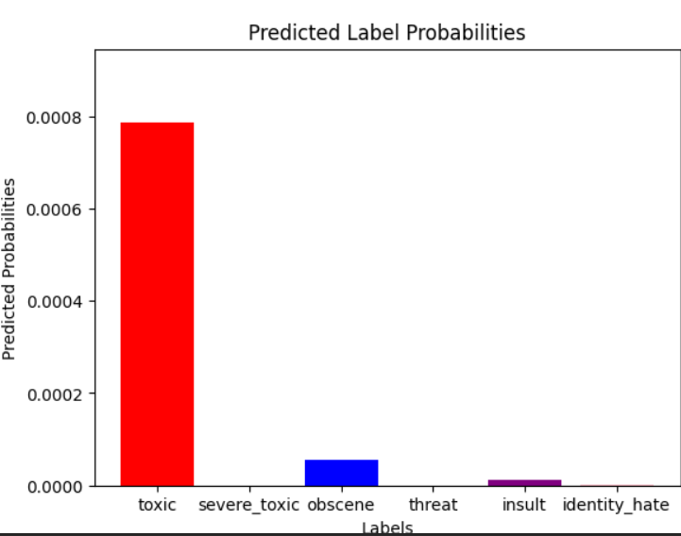

Figure 5. Percentage Of Toxicity In Toxic Comments Data.

In our train dataset only 8% of the data was toxic. Out of that 8%, 81% of the toxic comments made are insults, 8.37% are identity attacks, 7.20% are obscene, 3.35% are threats and a very small number of toxic comments are severely toxic.

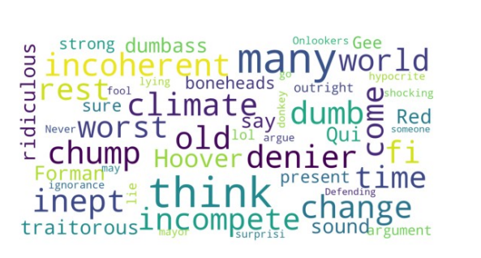
Figure 7. Prevalent comments with insult score > 0.75

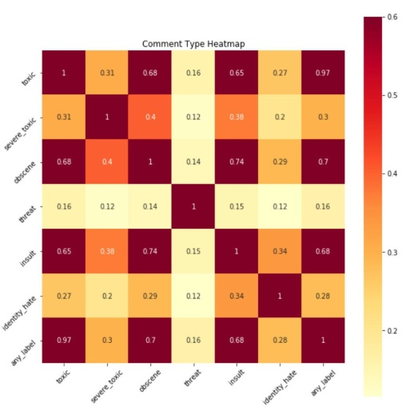
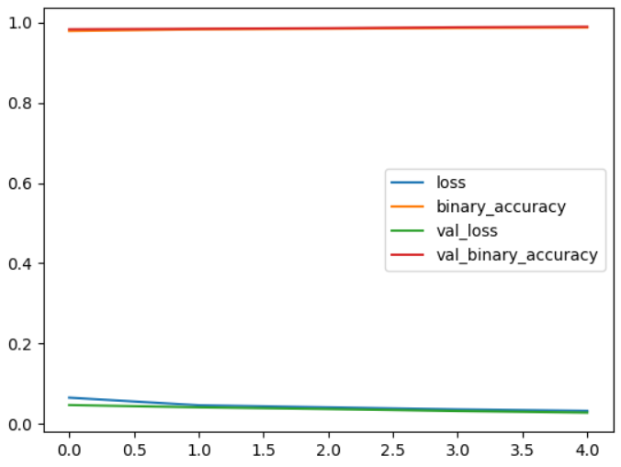

Figure 9. Loss curves of LSTMs Figure 10. Heat Map

5 Conclusion
The internet being a public platform, it is vital to ensure that people with different points of view can be heard without fear of being attacked. We chose the LSTM algorithm for improved accuracy after analyzing several techniques for solving the problem of online hazardous remark classification. The incorporation of such categorization algorithms into social media platforms to automatically categorize and filter out inappropriate or damaging comments would be a future focus of this research.

References

- Guggilla, C., Miller, T., &Gurevych, I. [2016, December]. Convolutional neural network-and LSTM-based claim classification in online user comments. In Proceedings of COLING 2016, the 26th International Conference on Computational Linguistics: Technical Papers (pp. 2740-2751).
- Mozafari, M., Farahbakhsh, R., & Crespi, N. (2019, December). A BERT- based transfer learning approach for hate speech detection in online social media. In International Conference on Complex Networks and Their Applications (pp. 928- 940). Springer, Cham.
- Jabreel, M., & Moreno, A. (2019). A deep learning-based approach for multi-label emotion classification in tweets. Applied Sciences, 9(6), 1123.
- [4] Haralabopoulos, Anagnostopoulos, I., & McAuley, D. (2020). Ensemble Deep Learning for MultilabelBinaryClassificationofUser-Generated Content. Algorithms, 13(4), 83.
- Sridharan, M., & Swapna, T. R. (2019, June). Amrita School of Engineering-CSEatSemEval-2019 Task 6: Manipulating attention with temporal convolutional neural network for offense identification and classification. In Proceedings of the 13th International Workshop on Semantic Evaluation (pp. 540-546).
- Mozafari, M., Farahbakhsh, R., & Crespi, N. (2019, December). A BERT-based transfer learning approach for hate speech detection in online social media. In International Conference on Complex Networks and Their Applications (pp. 928-940). Springer, Cham.
- Liang, J., Meyerson, E., Hodjat, B., Fink, D., Mutch, K., & Miikkulainen, R. (2019, July). Evolutionary neural automl for deep learning. In Proceedings of the Genetic and Evolutionary Computation Conference (pp. 401- 409).
- Kajla, H., Hooda, J., & Saini, G. (2020, May). Classification of Online Toxic Comments Using Machine Learning Algorithms. In 2020 4th International Conference on Intelligent Computing and Control Systems (ICICCS) (pp. 1119-1123). IEEE.
- Feurer, M., & Hutter, F. (2019). Hyperparameter optimization. In Automated Machine Learning (pp. 3-33). Springer, Cham.Zhang, X., Liao, Q., Kang, Z., Liu, B., Ou, Y., Du, J., ... & Fang, Z. (2019). Self-healing originated van der Waals homojunction with strong interlayer coupling for high-performance photodiodes. ACS Nano, 13(3), 3280-3291.
- Tabassi, E., Burns, K. J., Hadjimichael, M., Molina-Markham, A. D., & Sexton, J. T. (2019). A Taxonomy and Terminology of Adversarial Machine Learning.

